Taxonomy Carolus Linnaeus - The Scientist Who Named Living Things
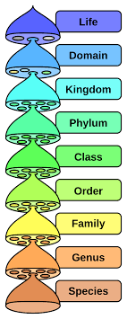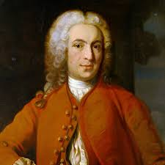
Carolus Linnaeus (1707–1778) was a Swedish scientist who created a system for naming and organizing living things. Because of this, he is often called the “Father of Taxonomy.”

Before Linnaeus, scientists used long and confusing names for plants and animals. Linnaeus made things much simpler.

What Linnaeus Did

He created a way to classify living things into groups.

He invented scientific names with two parts (called binomial nomenclature).

He helped scientists organize nature in a clear system.

For example:

Human scientific name: Homo sapiens
Dog scientific name: Canis familiaris
The first word tells the genus, and the second word tells the species.
Why He Is Important
Linnaeus’s system is still used today by scientists all over the world.
It helps scientists:
identify living things
avoid confusion between languages
understand how organisms are related

Fun Facts for Students

Linnaeus loved plants and nature as a child.
He helped create one of the first botanical gardens in Sweden.
His classification system is still used more than 250 years later.
He named thousands of plants and animals.
**********************************************************************************
Taxonomy is the way scientists organize and group living things so they are easier to study and understand — like sorting items into folders or categories.

For example, instead of studying every animal one by one, scientists group them by shared characteristics.
Think of it like this:
In school, students are grouped into classes
In a library, books are grouped by type
In science, living things are grouped by taxonomy
Scientists look at things like:
-body structure
-how animals move
-how plants grow
-whether something has a backbone

Then they place organisms into groups such as:
Kingdom
Phylum
Class
Order
Family
Genus
Species

Taxonomy is like a filing system for living things.
Simple way to explain the taxonomy levels:

Scientists sort living things from very big groups to very small groups. Each level becomes more specific.

Think of it like zooming in step by step.

Kingdom
This is the largest group. It includes many different living things.
Example: Animals, Plants, Fungi.

Phylum
This groups living things by their basic body plan.
Example: Animals with backbones belong to one phylum.

Class
This groups organisms that are even more alike.
Example: Mammals (animals with hair and that feed milk to babies).

Order
This groups animals that are very similar in behavior and structure.
Example: Carnivores (meat-eating mammals).

Family
This is a smaller group of closely related organisms.
Example: The dog family.

Genus
This is a very small group of organisms that are almost the same.
Example: Wolves, dogs, and coyotes share a genus.

Species
This is the most specific group.
A species is a group of organisms that are basically the same and can have babies together.
Example: Dogs.

Summary:

Taxonomy goes from big groups to small groups, helping scientists organize living things step by step.

Quick example

A dog is classified like this:
Kingdom: Animal
Class: Mammal
Species: Dog

So taxonomy helps scientists identify, name, and compare living things.

