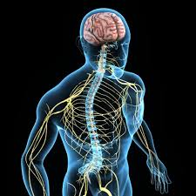

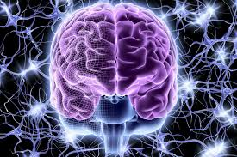

Nervous system
The nervous system is the body’s control and communication system. It helps your body sense things, think, move, and react.

Think of it like the body’s messenger network, sending information back and forth very quickly.

Main parts of the nervous system

- Brain
- The brain is the control center of the body. It helps you:

think
remember
feel emotions
control movement
make decisions

2. Spinal cord
The spinal cord is a long bundle of nerves that connects the brain to the rest of the body.
Messages travel between the brain and body through the spinal cord.

3. Nerves
Nerves are like tiny wires all over your body. They send messages:
from the body to the brain (like pain or temperature)
from the brain to the body (like telling muscles to move)

How the nervous system works (simple example)
If you touch something hot:
Nerves in your skin send a message.
The message travels to the spinal cord and brain.
Your brain sends a message back.
Your hand moves away quickly.
This happens in less than a second!

