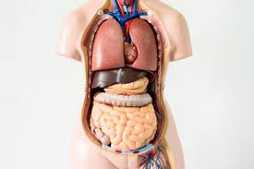 Stomach
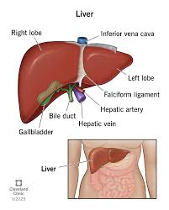
Small intensine
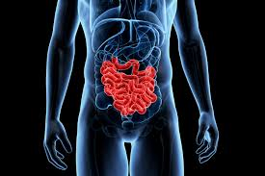
Large Intestine
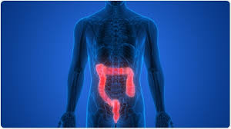
Small and large intestine
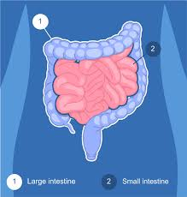

Pancreas
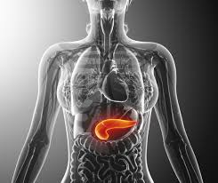
Lungs
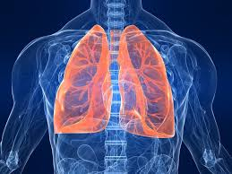
Heart
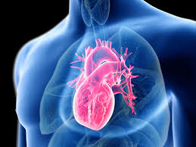
Kidneys
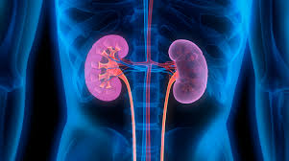
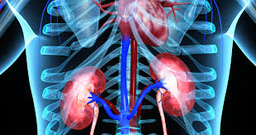
Appendix
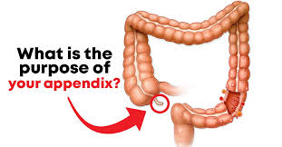
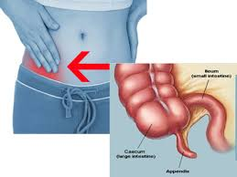
The appendix is a small organ in your body. It is attached to the large intestine, in the lower right side of your abdomen (belly).
Scientists believe the appendix may help the immune system, but people can live without it.
The appendix does not have a very important job in the body. Scientists think it may help the immune system by storing helpful bacteria that support digestion. However, people can live normally without an appendix.

Sometimes the appendix can get infected and swollen. This is called appendicitis, and doctors may need to remove it. After surgery, a person can still live a healthy life.

