The Amazon Rainforest

1. What Is the Amazon Rainforest?
The Amazon Rainforest is the largest rainforest in the world. It is located in South America and spreads across several countries, including Brazil, Peru, and Colombia.
The Amazon is full of rivers, tall trees, plants, and animals. Millions of different species live there.
Scientists believe that about one out of every ten known species on Earth lives in the Amazon rainforest.
Because the forest produces oxygen and helps control the Earth’s climate, people sometimes call it “the lungs of the Earth.”

2. How People Destroy the Amazon (Deforestation)
Deforestation means cutting down many trees in a forest. In the Amazon, people sometimes cut or burn trees to clear land.
This happens for several reasons:
• Farming – Land is cleared to grow crops such as soybeans.
• Cattle ranching – Large areas are used to raise cows for meat.
• Logging – Trees are cut to make wood products such as furniture and paper.
• Building roads and towns – New roads and cities require land.
When trees disappear, animals lose their homes and many plants and animals may disappear forever.

3. How People Living in the Forest Survive
Many Indigenous communities live in the Amazon rainforest. They have lived there for hundreds or even thousands of years.
People in the forest survive by:
• fishing in rivers
• growing small gardens with fruits and vegetables
• hunting animals for food
• collecting fruits, nuts, and plants from the forest
Many Indigenous groups try to protect the forest because their lives depend on it.

4. Animals in Danger
Many animals in the Amazon are now in danger because their habitats are being destroyed.
Examples include:
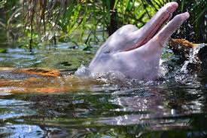
• Pink river dolphins
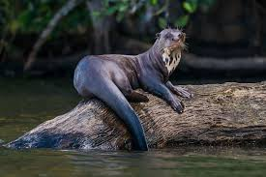
• Giant otters
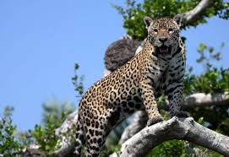
• Jaguars
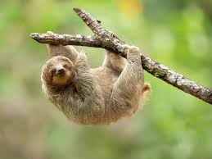
• Sloths
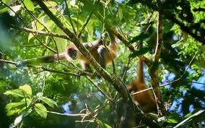
• Monkeys
• Many birds
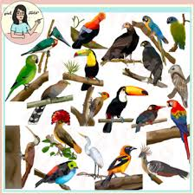

Reptiles
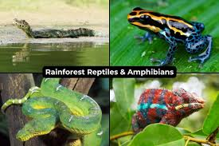
When forests are cut down or rivers become polluted, animals may lose their homes and food sources.

5. Climate Change and the Amazon
The Amazon plays an important role in Earth’s climate. Trees absorb carbon dioxide, a gas that contributes to global warming.
When forests are burned or cut down:
• carbon dioxide is released into the atmosphere
• the Earth becomes warmer
• weather patterns can change
This is why protecting rainforests is important for the entire planet.

6. What the World Can Do to Help
People around the world are working to protect the Amazon rainforest.
Some solutions include:
• protecting national parks and wildlife areas
• stopping illegal logging and hunting
• planting new trees
• supporting Indigenous communities
• using fewer products that cause deforestation
When people protect forests, they help protect animals, nature, and the future of our planet.

